|  |  |
| --- | --- |
| Date | 17 September 2022 |
| Team ID | PNT2022TMID39018 |
| Project Name | Gas leakage monitoring and alerting system for industries |
| Maximum Marks | 2 Marks |

**Step-1: Team Gathering, Collaboration and Select the Problem Statement**

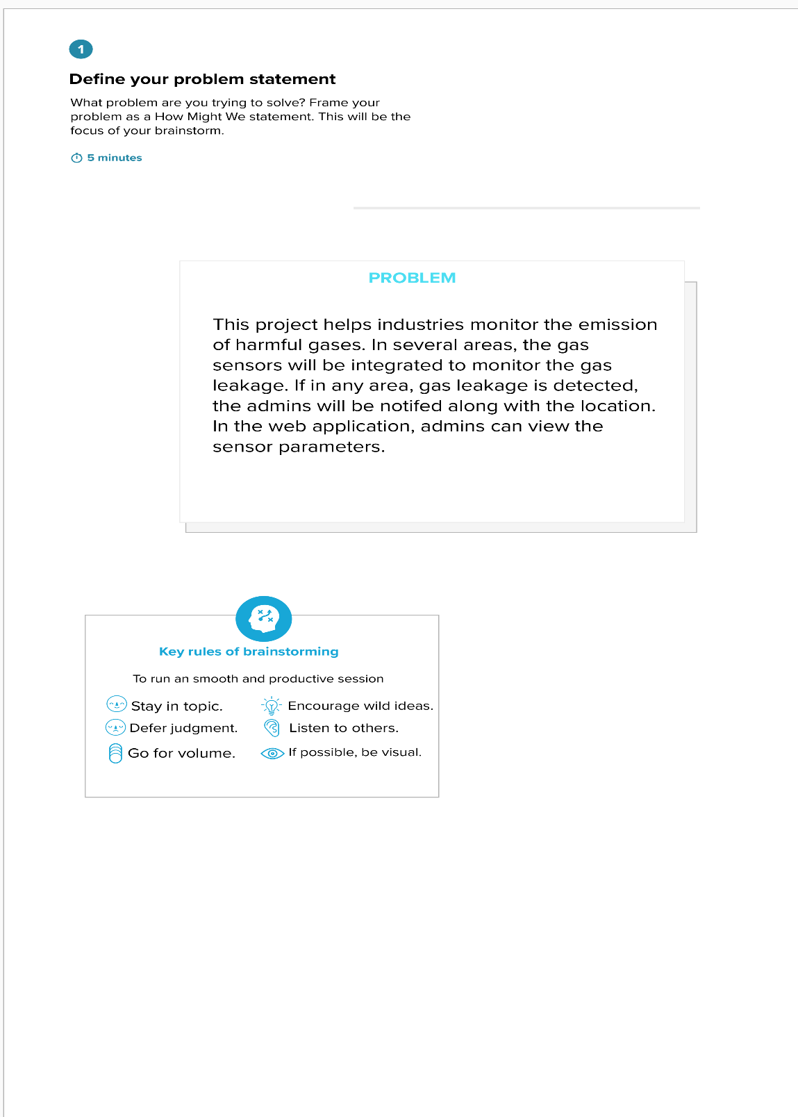

**Step-2: Brainstorm, Idea Listing and Grouping**

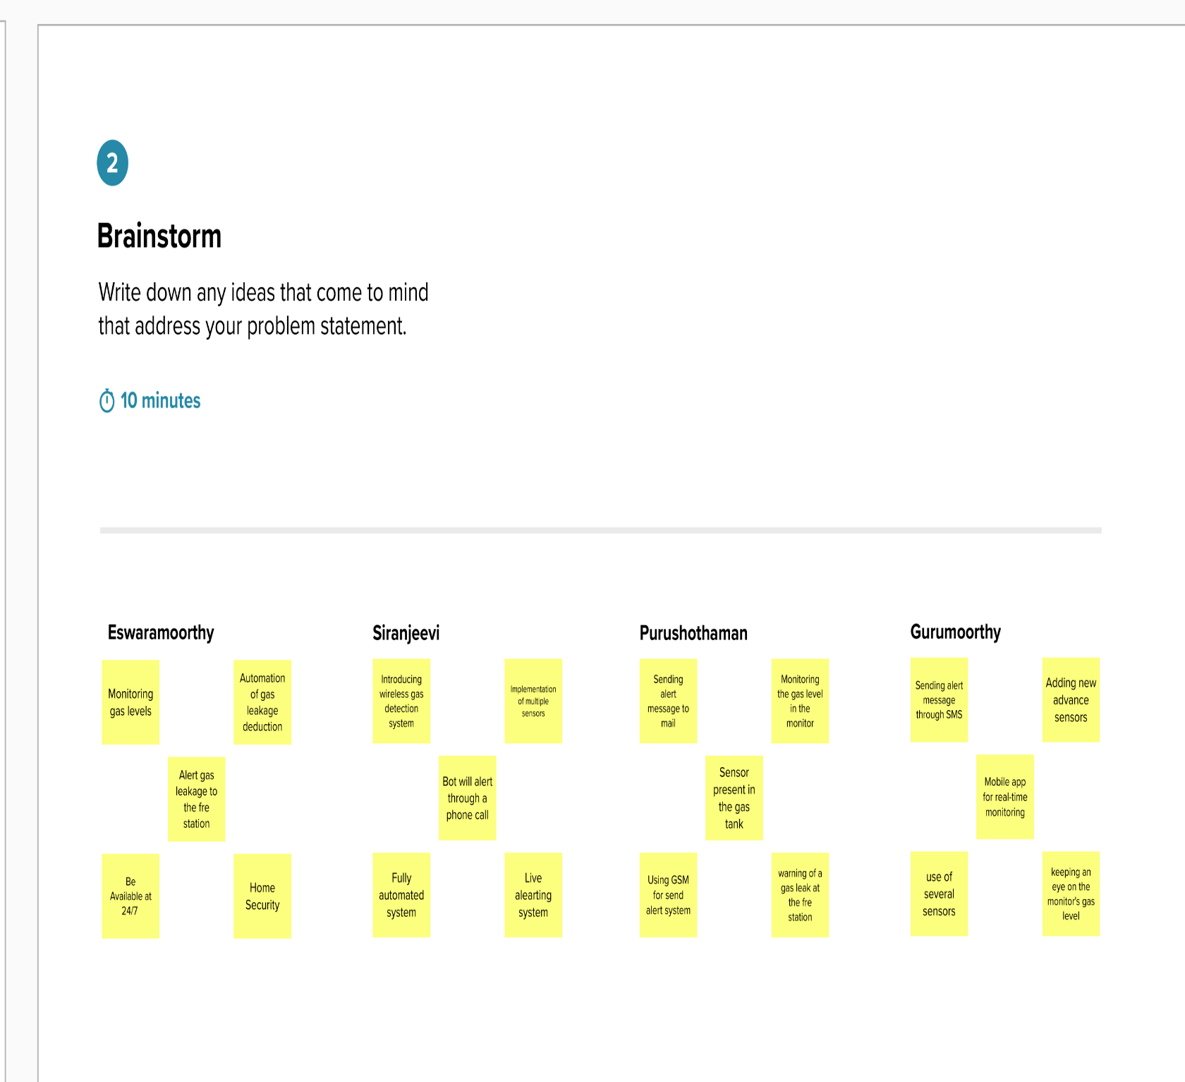

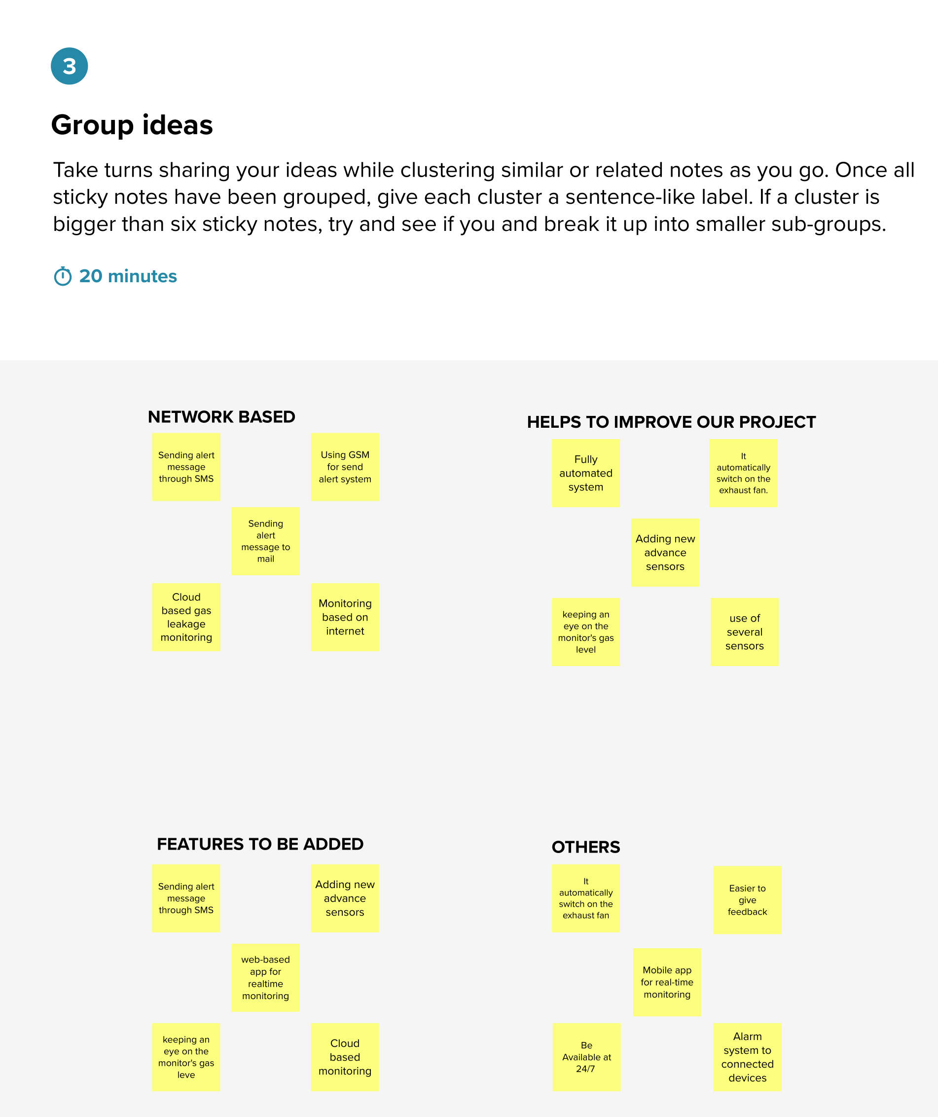

**Step-3: Idea Prioritization**

